OPEN TO ALL AGES!!

New Classes in 2026!

Open Class Questions: Kristi Gilbert (605) 290-3534
2026Dickey County Fair
Open Class Handbook

GENERAL OPEN CLASS RULES

- Entries for all classes shall be entered for exhibit from 8 to 10:30 A.M. on Friday, July 10, 2026. Closed Judging will begin at 11 A.M.
- Open class is open to any exhibitor regardless of age- you cannot enter the same project in the same year in both 4-H and Open but you are welcome to bring back ‘old’ projects from the previous year from 4-H to enter in open class!
- One blue, one red and one white ribbon will be awarded in each class lot .
- Each exhibitor is responsible for pickup of their exhibits and premiums. Any item not picked up by 6pm on Sunday, July 12th, 2026 will be donated to the nearest garbage can. Please plan accordingly!
- Premiums will be paid at checkout time, 4:00 P.M. on Sunday, July 12th, 2026.
- Premiums will be paid out as follows:
  - Blue-$5.00
  - Red-$3.00
  - White-$2.00
  - Best of Show in each Department-$10.00
- Each entry must have an entry slip filled out for it. They are found at the back of this book, online or the day of. It is suggested to use an address label for ease of entering on each slip.

2026 OPEN CLASS EXHIBIT AREAS

1. Baking:
Yeast Breads and Rolls, Cookies, Cakes, Pies and Candies

2. Hobbies:
Needlework and Crafts, Ceramics, Woodworking, Leathercraft, Silk flower arrangements, Cut flowers, Confectionery Decorating

3. Food Preservation:
Fruit, Vegetables, Jams & Jellies, Relishes & Sauces, Juices, Pickles, Dried Foods

4. Photography:
Black and white, Color

5. Horticulture and Agronomy:
Fruits and Vegetables, Grain and Forage (threshed grains, corn stalk displays and sheaves)
** NEW in 2026- Largest and Unique Vegetable Contest!**

6. Artwork:
Oil, Pastels, Pencil, Charcoal

7. Eggs

DIVISION 1- BAKING

Rules and Regulations for Division 1

1. NO packaged or prepared mixes, no commercially frozen dough or pie crusts
2. Place exhibits on firm paper plate and in a clear plastic bag, fasten w/ wire tie, or use a zip-lock bag.
3. Do not exhibit the entire food item- it is stated under each class how much to exhibit.
4. ALL food exhibits must be safe to eat without refrigeration! No cream pies.
5. Each exhibit is required to have a recipe accompanying it.
6. ALL FOODS WILL BE THROWN AWAY ON SUNDAY AT 4PM UNLESS YOU MAKE PRIOR ARRANGEMENTS.
Class 2- Quick Breads
Lot-
- Banana (1/3 Loaf)
- Pumpkin (1/3 Loaf)
- Zucchini (1/3 Loaf)
- Muffins (4)
- Other Quick Bread
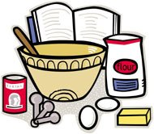
Class 1-Yeast Breads
Lot-
1. White (1/3 Loaf)
2. Whole/Cracked Wheat (1/3 Loaf)
3. Other Bread (1/3 Loaf)
4. Dinner Rolls-4
5. Other Rolls-4
6. Cinnamon/Caramel Rolls-2

Special Rules/Regulations for Bars, Cakes and Pies

1. Cut bars in uniform size for display (approximately 2-1/2” by 2-1/2”). Exhibit 3 bars.
2. Display all products on a paper plate, covered in a bag or saran wrap.
6. Pie recipes using raw eggs (whites or yolks) in the finished product are not allowed.
7. Baked meringues on the pies are allowed.
10. No cream or custard pies allowed!
Class 6 -Pies
(exhibit one representative piece of pie)
Lot-
- Apple
- Mixed Fruit
- Peach
- Pecan
- Other
Class 5 -Cakes (exhibit one representative piece/section of cake)
Lot-
- Angel Food
- Sponge Cake
- Jelly Roll
- Other Cake
Class 3 -Bars (exhibit 3)
Lot-
- Brownies (3)
- Any other (3)

Class 4- Cookies (exhibit 3)
Lot-
- Dropped Cookie
- Rolled Cookie (cut outs)
- Other Cookie

Special Rules and Regulations for Class 7- Candy

1. All entries must be homemade
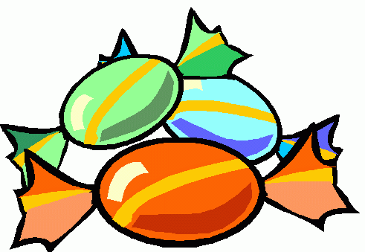
2. Each entry should be 4-6 pieces
3. All caramels and fudges should be cut into 1-inch squares

Class 7-Candies
Lot- **May enter up to 4 entries in this lot**
1. Any Candy

Special Rules and Regulations for Class 8- Cake Decorating

Rules-
1. Judging will be based on creativity, artistry, skill and NOT taste.
2. Item MUST be decorated by an exhibitor, using any methods.

Class 8- Cake Decorating
Lot -
1. Cake (exhibit entire cake)
2. Cookie (exhibit 1-2 cookies)
3. Cupcake (exhibit 1-2 cupcakes)
4. Any other

DIVISION 2-HOBBIES
Class 1-Needlework and Crafts
Lot-
1. Afghans (any method/type)
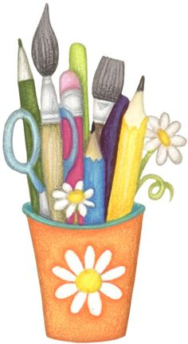
2. Items done on loom
3. Any other crocheted item
4. Any knitted item
5. Latchhook Items
6. Hardanger
7. Counted Cross Stitch
8. Candle Wicking
9.Quilts- Full to King Size
10. Quilts- Baby
11. Quilts- Wall hanging
12. Embroidery Items
13. Needlepoints Items
14. Any Ceramics
15. Any other Craft Items

Class 2-Woodworking
Lot- (May enter 3 items in each lot)
1. Item under 12 inches tall for decorative purposes
2. Item over 24 inches tall for decorative purposes
3. Chainsaw Art

Class 3- Leathercraft
Lot- (May enter 3 Items in each lot)
1. Item Made with stamping, carving, etc.


Class 4-Flower Arrangements (Silk and Real)
Lot- (May enter up to 3 exhibits per lot)
1.Silk Flower Arrangement
2. Silk Flower Corsage/ Boutonniere
3. Cut Flower (Real) Arrangement
4. Cut Flower Corsage/ Boutonniere
5. Other Floral Arrangement

Class 5 Cut Flowers
Rules-
1. Flowers must be grown by the person whose name is on the entry.
2. Only one exhibit per lot. You may enter as many lots as like.
3. Exhibits must have exact number of stems indicated, otherwise disqualified
4. Cut flowers will be judged on uniformity, size, color, stem substance, and foliage.
5. Exhibitors must furnish containers for display. Fair not responsible for containers.
Lot-
- Aster, 3 stems
- Baby’s Breath, 1 spray
- Calendula, 3 stems
- Carnation, 3 stems
- Celosia, 3 stems
- Dianthus, 3 stems
- Phlox, 3 stems
- Petunia, 1 spray or 3 blooms
- Gladiolas, 1 spray
- Hollyhock, 1 spray

- Roses, 3 blooms
- Snapdragon, 3 stems
- Columbine, 3 stems
- Lilies, 1 spray
- Cosmos, 3 stems
- Dahlia, 3 blooms
- Marigold, 3 stems
- Sunflower, 3 stems
- Verbena, 3 stems
- Delphinium, 1 spray
- Zinnia, 3 stems
- Pansy, 3 stems
- Any other

DIVISION 3-FOOD PRESERVATION
1. All canned food exhibits must be processed according to USDA Standards and exhibited in regulation canning quart, pint, or half-pint jars. (For correct food preservation procedures and processing time, refer to Extension publications which are available at the Dickey County Extension Office.)
2. All exhibits must be labeled with date processed and contents of jar.
3. All jars must be filled to at least 1/2 inch from the top of the jar or otherwise proper headspace for the product.
Class 4- Relishes/Sauces/Juice
Lot-
- Relish
- Salsa
- Other Sauce
- Other Juice

Class 3-Jams and Jellies
Lot- (may enter 2 in each lot)
- Jam
- Jelly
- Preserve
- Syrups
- Other
Class 2-Vegetables
Lot-
- Beans
- Tomato
- Beets (Plain)
- Other
Class 1-Fruit
Lot-
- Pear
- Peaches
- Cherries
- Native Fruits
- Other

Class 5-Pickles
Lot-
- Beets
- Cucumber, Dill
- Cucumber, Sweet
- Watermelon
- Sauerkraut
- Other Pickled Vegetable
- Other Pickled Product

Class 6-Dried Foods
Lot-
- Dehydrated Fruit -4
- Dehydrated Vegetable-4
- Dehydrated Jerky-4
- Freeze Dried Product -4
- Fruit Leather-4
- Dried Herbs- 2 Tbsp
- Other Dried Product

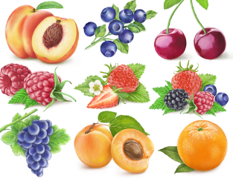

DIVISION 4-PHOTOGRAPHY

Special Rules and Regulations for Division 4

1. All photographers must be Amateurs, NO Professional photographers!
2. Each entry must be your own work.
3. Only one entry per lot number.
4. All photographs must be matted or framed. Frames or mattes are not judged. NO GLASS PLEASE! Simple matting on poster board is acceptable.
5. All pictures must be no smaller than a 5"x7" or no larger than a 16"x20".
6. Place a label on the back of the picture with name and lot number.


Class 1-Black and White Class 2- Color
Lot- Lot-
1. People 1. People
2. Landscape 2. Landscape
3. Animals 3. Animals
4. Any other 4. Any other

DIVISION 5-HORTICULTURE/AGRONOMY

1. Fruit and vegetable exhibits should be displayed on a paper plate or Styrofoam tray.
2. All Vegetables should be clean.
3. Root crops should be cut with 1" tops.

Class 1-Fruits and Vegetables **May enter 2 in each lot**
Lot-
- Beans-3 pods
- Beets-3
- Broccoli- 1head
- Cabbage- 1head
- Carrots -3
- Cauliflower – 1head
- Celery- 1 bunch
- Corn- 3 ears shucked
- Cucumbers -3
- Dill- 3 heads
- Eggplant -1
- Garlic- 3
- Kohlrabi-1
- Lettuce- 1 head or 3 leaves
- Onions -3
Lot-
16. Tomatoes-3
17. Peas-3
18. Cantaloupe-1
19. Potatoes -3
20.Watermelon-1
21. Spinach-3 plants
22. Summer Squash-1
23. Swiss Chard- 1 plant
24. Other Vegetable
25.Plums -3
26.Raspberries-10
27.Strawberries-10
28. Crapapples-5
29. Chokecherries-20
30. Apples -3
31. Rhubarb-3 stalks
32. Other Fruit



Grain and Forage Rules:
1. Harvested grain and seed must be from this year or last year's crop.
2. Small grain sheaves must be stripped of all leaves if headed and all roots removed.
3. Sheaves must be 2 1/2" to 3" in diameter halfway between butt and head and bound in 3 to 4 places with cord.
4. Forage sheaves must be 3 to 4 inches in diameter at the butt and bound at the butt and 2 or 3 other places.
5. Each grain sample must be 1 quart in quantity.
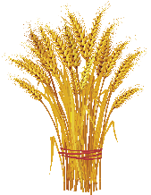
Class 2-Grain and Forage **May enter 2 in each lot**
Lot-
1. Small grain, any kind 4. Corn (5 ears)
2. Soybeans 5. Grain sheaves, any kind
3. Sunflowers (1 head) 6. Forage sheaves, any kind
7. Corn (3-5 stalks bound together)

Class 3- Largest and Unique Vegetable **NEW IN 2026!** $10.00 cash prize!
Lot-
      - Largest Vegetable by weight
      - Most Unique Vegetable/ Fruit
NEW!

DIVISION 6-ARTWORK
1. All work must be original and produced by the exhibitor.
2. Limited to two (2) entries per lot number.

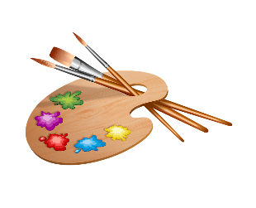
Lot -
1. Oil/ Pastel
2. Watercolor/Acrylic Paint/ Paint
3. Pencil
4. Charcoal
5. Other

DIVISION 7-Eggs
1. Eggs should be clean and dry in any style 12 pack carton. You may cut the carton in half if you wish.

Class 1-Poultry
Lot-
1. Chicken eggs (6 eggs)
2. Other Eggs (6 eggs)

2026 Dickey County Fair Open Class Entry
Name:_____________________________________________________________
Address:___________________________________________________________
Phone Number:______________________________________________________
Division:__________ Class:________ Lot:__________
Description:________________________________________________________

2026 Dickey County Fair Open Class Entry
Name:_____________________________________________________________
Address:___________________________________________________________
Phone Number:______________________________________________________
Division:__________ Class:________ Lot:__________
Description:________________________________________________________

2026 Dickey County Fair Open Class Entry
Name:_____________________________________________________________
Address:___________________________________________________________
Phone Number:______________________________________________________
Division:__________ Class:________ Lot:__________
Description:________________________________________________________

2026 Dickey County Fair Open Class Entry
Name:_____________________________________________________________
Address:___________________________________________________________
Phone Number:______________________________________________________
Division:__________ Class:________ Lot:__________
Description:________________________________________________________

2026 Dickey County Fair Open Class Entry
Name:_____________________________________________________________
Address:___________________________________________________________
Phone Number:______________________________________________________
Division:__________ Class:________ Lot:__________
Description:________________________________________________________

